# **Hardware**

Breadboard Isolation

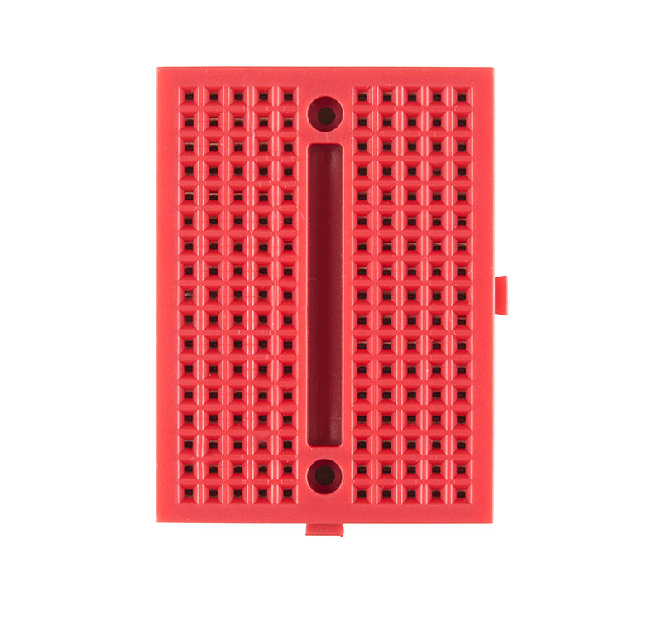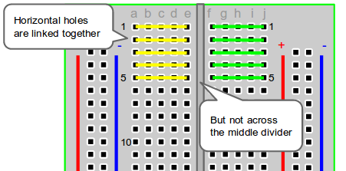

* Rows get the same signal (e.g., power, gnd, output)
* Wires go from the sensors to individual breadboards to consolidate ground and power wires
  + Signal wires kept in separate rows

## **Temperature Sensor: TMP36**

<https://www.mouser.com/datasheet/2/609/TMP35_36_37-1504323.pdf>

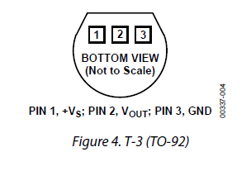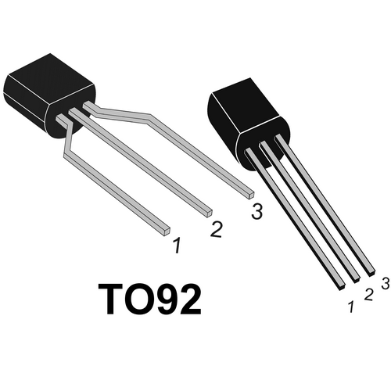

## **Salinity Sensor**

<https://www.fecegypt.com/uploads/dataSheet/1480850810_water.pdf>

* It’s supposed to take 5volts input, 0-4.2volts output
  + SparkFun ADC may only be able to take 0-3.3volts*
  + Sara suggests adding resistors to bring down the sensor output voltage
  + Boost converter to bring up the power input voltage from 3 to 5volts
* Markings on the sensor indicate power (+), ground (-), signal (S)
* Actually a depth sensor
  + Salinity changes conductivity so we could use it to measure the salinity of the water

## **Turbidity Sensor**

<http://www.farnell.com/datasheets/1855958.pdf?_ga=2.39845411.1294115367.1581449301-1258927194.1581449301>

<https://www.electroschematics.com/diy-water-quality-meter-using-a-turbidity-sensor/>

## Insolation Sensor

<https://www.tme.com/Document/01ba1573cea1124ddd9a55cccc53ed63/all.pdf>

## Battery Pack

* Commonly available
* Two AA batteries output 2*1.5 = 3volts

# Instructions

1. Follow pin assignments on sensor datasheets and SparkFun diagram for wiring

ESP32 pinout: <https://cdn.sparkfun.com/datasheets/Wireless/WiFi/ESP32ThingV1.pdf>

## Assembling the Bouy on a Breadboard:

**Step 1 – SparkFun ESP32 Thing:** Place the *SparkFun ESP32 Thing* PCB on a breadboard, preferably at the end of the board, with the USB port facing the edge *(insert image here)*

**Step 2 – Photoresistor Sensor:** Place the Salinity sensor onto the board, each lead into its own row (lead polarity does not matter). Connect the two terminals to its own rows